**PIZZA SALES SQL QUERIES**

**KPI’S**

1. **Total Revenue:**

**select round(sum(total_price)) as Total_Revenue from orders**

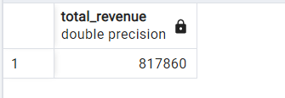

1. **Average Order Value:**

**select sum(total_price)/count(distinct(order_id)) as Average_Order_Value from orders**

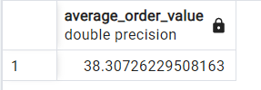

1. **Total Pizzas Sold:**

**select sum(quantity) as Total_Pizzas_Sold from orders**

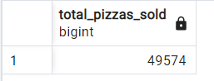

1. **Total Orders:**

**select count(distinct(order_id)) as Total_orders from orders**

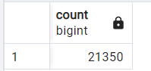

1. **Average Pizzas Per Order**

**select cast(cast(sum(quantity) as decimal(10, 2))/**

**cast(count(distinct(order_id)) as decimal(10, 2)) as decimal(10, 2)) as Avg_Pizzas_Per_order from orders**

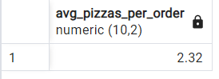

**Charts Requirements**

1. **Daily Trend for Total Orders:**

**SELECT**

**to_char(order_date, 'day') AS order_day,**

**COUNT(DISTINCT (order_id)) AS total_orders**

**FROM**

**orders**

**GROUP BY**

**order_day**

**order by**

**total_orders desc**

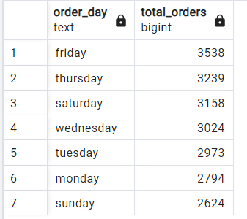

1. **Monthly Trend for Total Orders:**

**SELECT**

**to_char(order_date, 'month') AS month_name,**

**COUNT(DISTINCT (order_id)) AS total_orders**

**FROM**

**orders**

**GROUP BY**

**month_name**

**order by**

**total_orders desc**

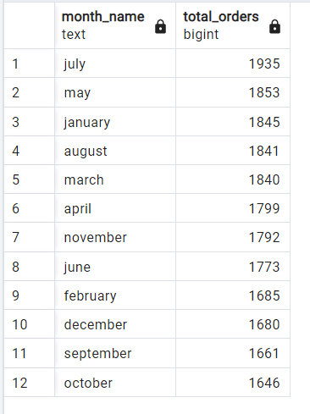

1. **Percentage of Sales by Pizza Category:**

**select Pizza_category, cast((sum(total_price) * 100 /**

**(select sum(total_price) from orders)) as decimal(10, 2)) as Sales_Perc**

**from orders**

**group by Pizza_category**

**order by Sales_Perc desc**

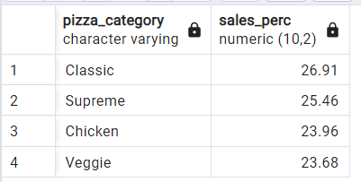

**To add a month filter:**

select Pizza_category,

cast((sum(total_price) * 100 / (select sum(total_price) from orders

where extract(month from order_date) = 10))

as decimal(10, 2)) as Sales_Perc

from orders

where extract(month from order_date) = 10

group by Pizza_category

order by Sales_Perc desc

1. **Percentage of Sales by Pizza Size**

**select pizza_size, cast(sum(total_price) as decimal(10, 0)) as Total_Sales, cast(sum(total_price)*100/**

**(select sum(total_price) from orders) as decimal(10, 2)) as Sales_Percentage**

**from orders**

**group by pizza_size**

**order by Sales_Percentage desc**

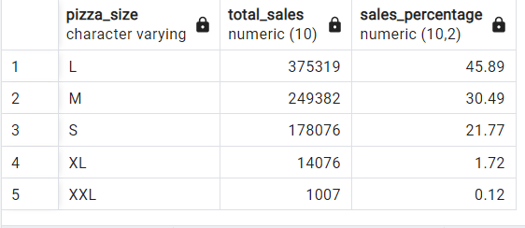

1. **Top 5 and Bottom 5 sellers by revenue, total quantity and total orders.**

**Top 5 by revenue:**

**select pizza_name, sum(total_price) as total_sales**

**from orders**

**group by pizza_name**

**order by total_sales desc**

**limit 5**

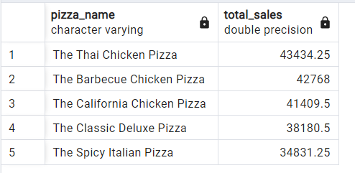

**Bottom 5 by Revenue:**

**select pizza_name, sum(total_price) as total_sales**

**from orders**

**group by pizza_name**

**order by total_sales**

**limit 5**

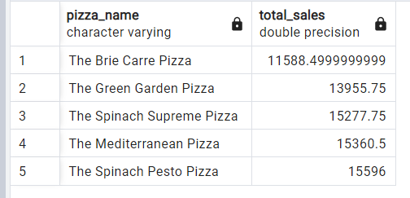

**Top 5 by Total Quantity:**

**select pizza_name, sum(quantity) as total_quantity**

**from orders**

**group by pizza_name**

**order by total_quantity desc**

**limit 5**

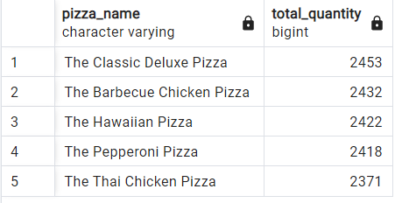

**Bottm 5 by Total Quantity:**

**select pizza_name, sum(quantity) as total_quantity**

**from orders**

**group by pizza_name**

**order by total_quantity**

**limit 5**

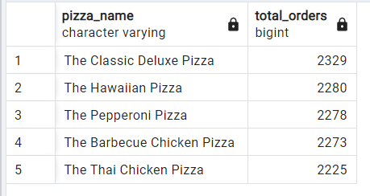

**Top 5 by Total Orders:**

**select pizza_name, count(order_id) as Total_orders**

**from orders**

**group by pizza_name**

**order by Total_orders desc**

**limit 5**

**Bottom 5 by Total Orders:**

**select pizza_name, count(order_id) as Total_orders**

**from orders**

**group by pizza_name**

**order by Total_orders**

**limit 5**

